**Data Visualization in Pandas with df.plot(): A Concise Guide**



Did you know that Pandas isn’t just for wrangling data? It’s also got some pretty neat visualization capabilities! Yep, that’s right. Hidden within this powerhouse library, widely loved for its data manipulation prowess, are tools that can help you turn those complex datasets into insightful visuals. Thanks to its partnership with Matplotlib, creating plots directly from your DataFrames is straightforward and efficient. So, whether you’re trying to get a quick glance at your data’s story or aiming to share detailed insights, Pandas has got you covered. Let’s explore how you can tap into this visual side of Pandas and make your data analysis even more impactful.

**The DataFrame.plot() Method**

At the heart of Pandas plotting is the .plot() method. It can generate a variety of plot types with minimal syntax by automatically using the DataFrame’s index as the x-axis and the columns as values for the y-axis.

Example syntax:

DataFrame.plot(x=None, y=None, kind='line', ax=None, subplots=False, sharex=True, sharey=False, layout=None, figsize=None, use_index=True, title=None, grid=None, legend=True, style=None, logx=False, logy=False, loglog=False, xticks=None, yticks=None, xlim=None, ylim=None, rot=None, fontsize=None, colormap=None, table=False, yerr=None, xerr=None, secondary_y=False, sort_columns=False, **kwds)

**Key Parameters**

* **x, y**: Labels of the DataFrame to be used on the x and y axes, respectively.
* **kind:** The type of plot to produce:
* ‘line’ (default): Line plot
* ‘bar’: Vertical bar plot
* ‘barh’: Horizontal bar plot
* ‘hist’: Histogram
* ‘box’: Box plot
* ‘kde’ or ‘density’: Kernel Density Estimation plot
* ‘area’: Area plot
* ‘pie’: Pie plot
* ‘scatter’: Scatter plot (requires x and y)
* ‘hexbin’: Hexbin plot (requires x and y)
* **ax:** An instance of Matplotlib’s Axes object. If not provided, uses the current axes.
* **subplots:** If True, each DataFrame column will be plotted on a separate subplot.
* **sharex, sharey**: If True (default for sharex), the subplots will share the x or y axis.
* **layout**: Tuple indicating the layout of subplots (rows, columns).
* **figsize**: A tuple (width, height) in inches for the figure size.
* **use_index**: Whether to use the DataFrame index for plotting on the x-axis.
* **title**: Title for the plot.
* **grid**: Whether to show grid lines.
* **legend**: If True, display a legend.
* **style**: Style string or list of strings, passed to Matplotlib for customizing lines.
* **logx, logy, loglog**: If True, use log scaling on the x-axis, y-axis, or both axes, respectively.
* **xticks, yticks**: Values for the x-axis and y-axis ticks.
* **xlim, ylim**: Limits for the x-axis and y-axis values.
* **rot**: Rotation for x-axis labels.
* **fontsize**: Font size for x-ticks and y-ticks.
* **colormap**: Colormap name or object for plot elements.
* **table**: If True, display a table of the numerical data in the DataFrame.
* **yerr, xerr**: Data for error bars in the y or x direction.
* **secondary_y**: If True, plot the y-axis on the right.
* **sort_columns**: Sort column names to plot if subplots=True.

To demonstrate basic plotting with Pandas and how to customize these plots, let’s work with a simple example dataset. Imagine we have a dataset containing monthly sales data for two products over one year. Here’s how we can visualize and customize plots of this data using Pandas.

First, let’s create our example dataset:

import pandas as pd  
import numpy as np  
import matplotlib.pyplot as plt  
  
# Sample data: Monthly sales for Product A and Product B  
data = {  
 'Month': ['Jan', 'Feb', 'Mar', 'Apr', 'May', 'Jun', 'Jul', 'Aug', 'Sep', 'Oct', 'Nov', 'Dec'],  
 'Product A': np.random.randint(100, 200, size=12),  
 'Product B': np.random.randint(80, 160, size=12)  
}  
  
df = pd.DataFrame(data)  
df = df.set_index('Month')

Here’s a head view of the dataset

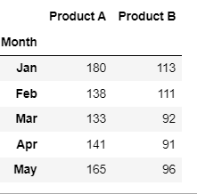

**Basic Plotting**

**Line Plot**

A line plot is perfect for visualizing the sales trend of these products over the months.

plt.figure(figsize=(10,8))  
df.plot(kind='line', marker='o', color=['green', 'blue'], title='Monthly Sales')  
plt.xlabel('Month')  
plt.ylabel('Sales')  
plt.legend(['Prod A - Green', 'Prod B - Blue'])  
plt.grid(True)  
plt.show()

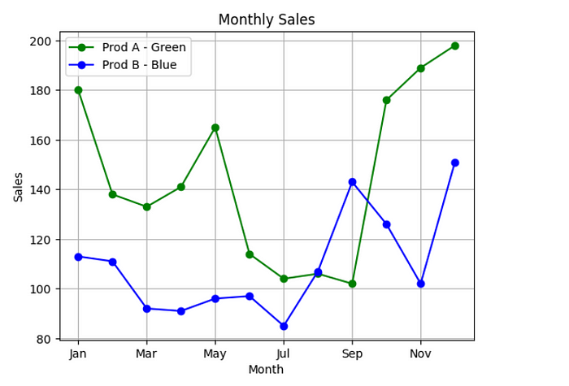

**Bar Plot**

Bar plots help compare the sales figures of Product A and Product B across different months.

plt.figure(figsize=(10, 6))  
df.plot(kind='bar', alpha=0.75, rot=45, color=['darkorange', 'darkblue'], title='Monthly Sales Comparison')  
plt.xlabel('Month')  
plt.ylabel('Sales')  
plt.show()

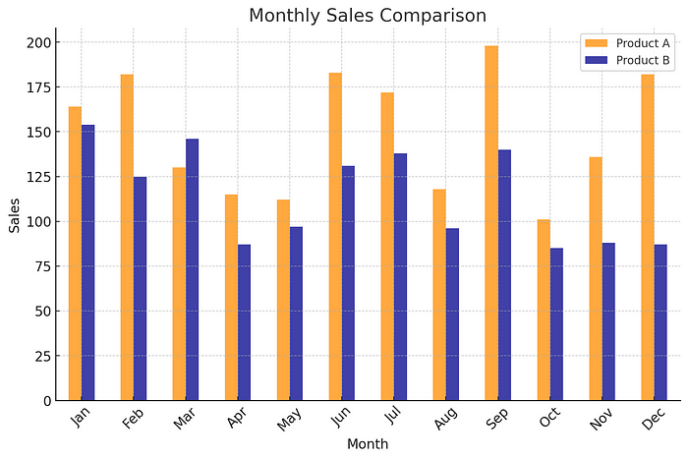

**Box Plots:**

Provides a visual summary of the central tendency, dispersion, and skewness of the data and identifies outliers.

plt.figure(figsize=(10, 6))  
color = {'boxes': 'DarkGreen', 'whiskers': 'DarkOrange', 'medians': 'DarkBlue', 'caps': 'Gray'}  
df.plot(kind='box', title='Sales Distribution for Product A and Product B', color=color)  
plt.ylabel('Sales')  
plt.show()

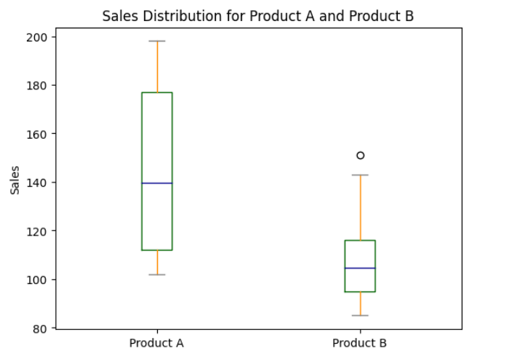

**Histograms:**

Visualize the distribution of sales for Product A with a histogram, customizing the number of bins.

plt.figure(figsize=(10, 6))  
df['Product A'].plot(kind='hist', bins=6, color='purple', edgecolor='black', title='Sales Distribution of Product A')  
plt.xlabel('Sales')  
plt.show()

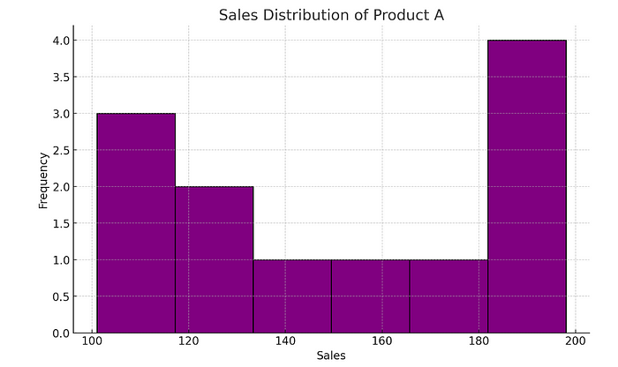

**Creating Subplots**

Subplots are useful for comparing different datasets or viewing different aspects of a dataset side by side.

fig, ax = plt.subplots(nrows=2, ncols=1, figsize=(10, 8))  
  
df['Product A'].plot(ax=ax[0], color='blue', title='Product A Sales Over Time')  
df['Product B'].plot(ax=ax[1], color='green', title='Product B Sales Over Time')  
  
plt.tight_layout()  
plt.show()

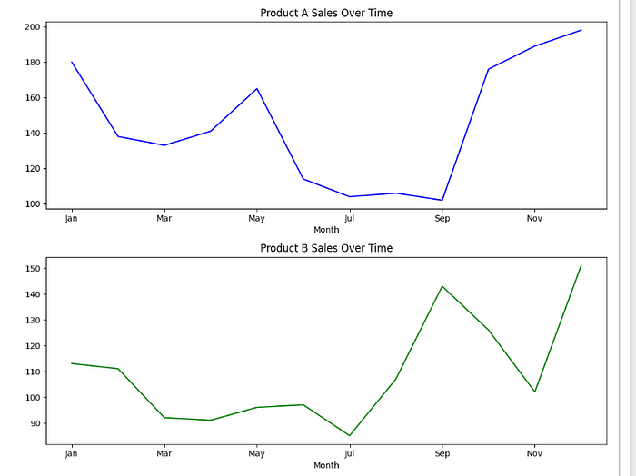

In this way you can create quick plots using pandas. for more details on the df.plot() visit the [**official documentation**](https://pandas.pydata.org/docs/reference/api/pandas.DataFrame.plot.html)

**Conclusion:**

In conclusion, Pandas’ `df.plot()` offers a straightforward yet powerful way to visualize data directly from DataFrames.With its seamless integration with Matplotlib and a wide array of plot types and customization options, it enables quick insights into complex datasets, facilitating effective data storytelling. Whether you’re a seasoned data scientist or just starting out, mastering `df.plot()` can significantly enhance your data visualization capabilities, turning raw data into actionable insights with minimal effort.